FiiO D3
User manual
Read this instruction carefully before using the product

Introduction to FiiO D3—Optical/Coaxial R/L Analog convertor

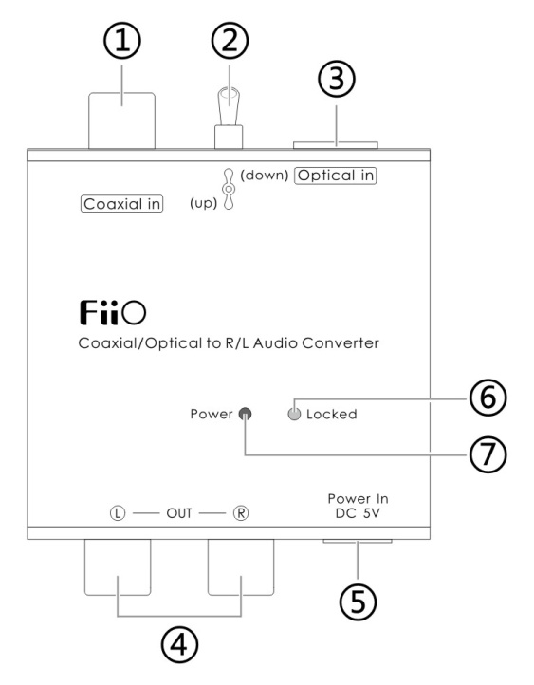
- Digital signal coaxial input port:
- Coaxial/Optical switch:
Put it upward is coaxial ,
downward is optical
- Digital signal optical input port
- Analog audio signal RCA L/R output port
- USB power supply input: DC5V
- Indicated light for signal status: when machine work, the blue light on.
- Power indicator: when power on, red light is on; power off, the light off.

Specification:

●Power supply | DC 5V
●Output amplitude | 1.6V（0dB Fs）
●Frequency Response | 20Hz~20KHz
●Signal to Noise Ratio | ≥90dB
●Crosstalk | 75dB
●Total harmonic distortion | <0.01%(10mW)
●Size | 61.6mm×49.1mm×21mm
● Weight | 50g

D3 BRIEF INSTRUCTION
D3 is a digital audio analog convertor, which can transfer digital audio (optical/coaxial) to two channels analog audio and amplify the output (but using directly on headphone is not recommended), just suitable for using together with the devices such as digital television, CD/DVD/Blue-ray player etc., which with coaxial or optical digital signal output.

Feature and main function:
●Built-in high-performance phase locked loop (PLL), with extra-low JITTER digital receiver chip WM8805.
●Maximum support 192KHz/24bit audio signal
●Optical/coaxial optional input function
● 2 channels standard RCA output port
● Indication for digital receiving status (LOCKED)
● MINI USB power supply port

Package list (Please verify if you received items below)
D3 1PCS
Power adaptor 1PCS
User manual 1PCS

IMPORTANT NOTE

Important note:
★Please keep the device dry and far away from moisture and humid environment，such as rain and any liquid or water with corrosion that will damage the device
★Do not try to open ，repair the device and place it near a source of liquid
★Please see to it that original power supply are required，or high quality power supply with voltage range with 5V200mA ，without warranty when the device be damaged by the third party using unsuitable power supply
★ If the native machine cannot work normally or any other questions, please visit our website ( http://www.fiio.com.cn/support/FeekBack.aspx ) to post comments or send email to service@fiio.com.cn

Cannot work or abnormal to work：
●with no sound output or with distortion, please be sure that the audio source and music file is not damaged, or try to re-plug the USB power
●Music input connector might have a faulty or unsuitable connection ，please reconnect the plug
●Please use the include stock cable or a compatible frequency connect cable in order to ensure a secured output

Qualified Certificate V00
DATE: Guangzhou FiiO Electronic Technology Ltd.
（dd-mm-yyyy） Tel: 020-62679040 Fax: 020-62679042
Address: 2/F, F Building, Hougang Industrial Zone, Shigang Village,
Huangshi West Road, Baiyun District, Guangzhou, China.
http:// www.fiio.com.cn Postcode：510430
QC: 5190064
Manufactured by Fiio Made in china

